Jenny Huang

19 January 2016

COMP-630: Computer Graphics

Scenes for HW4

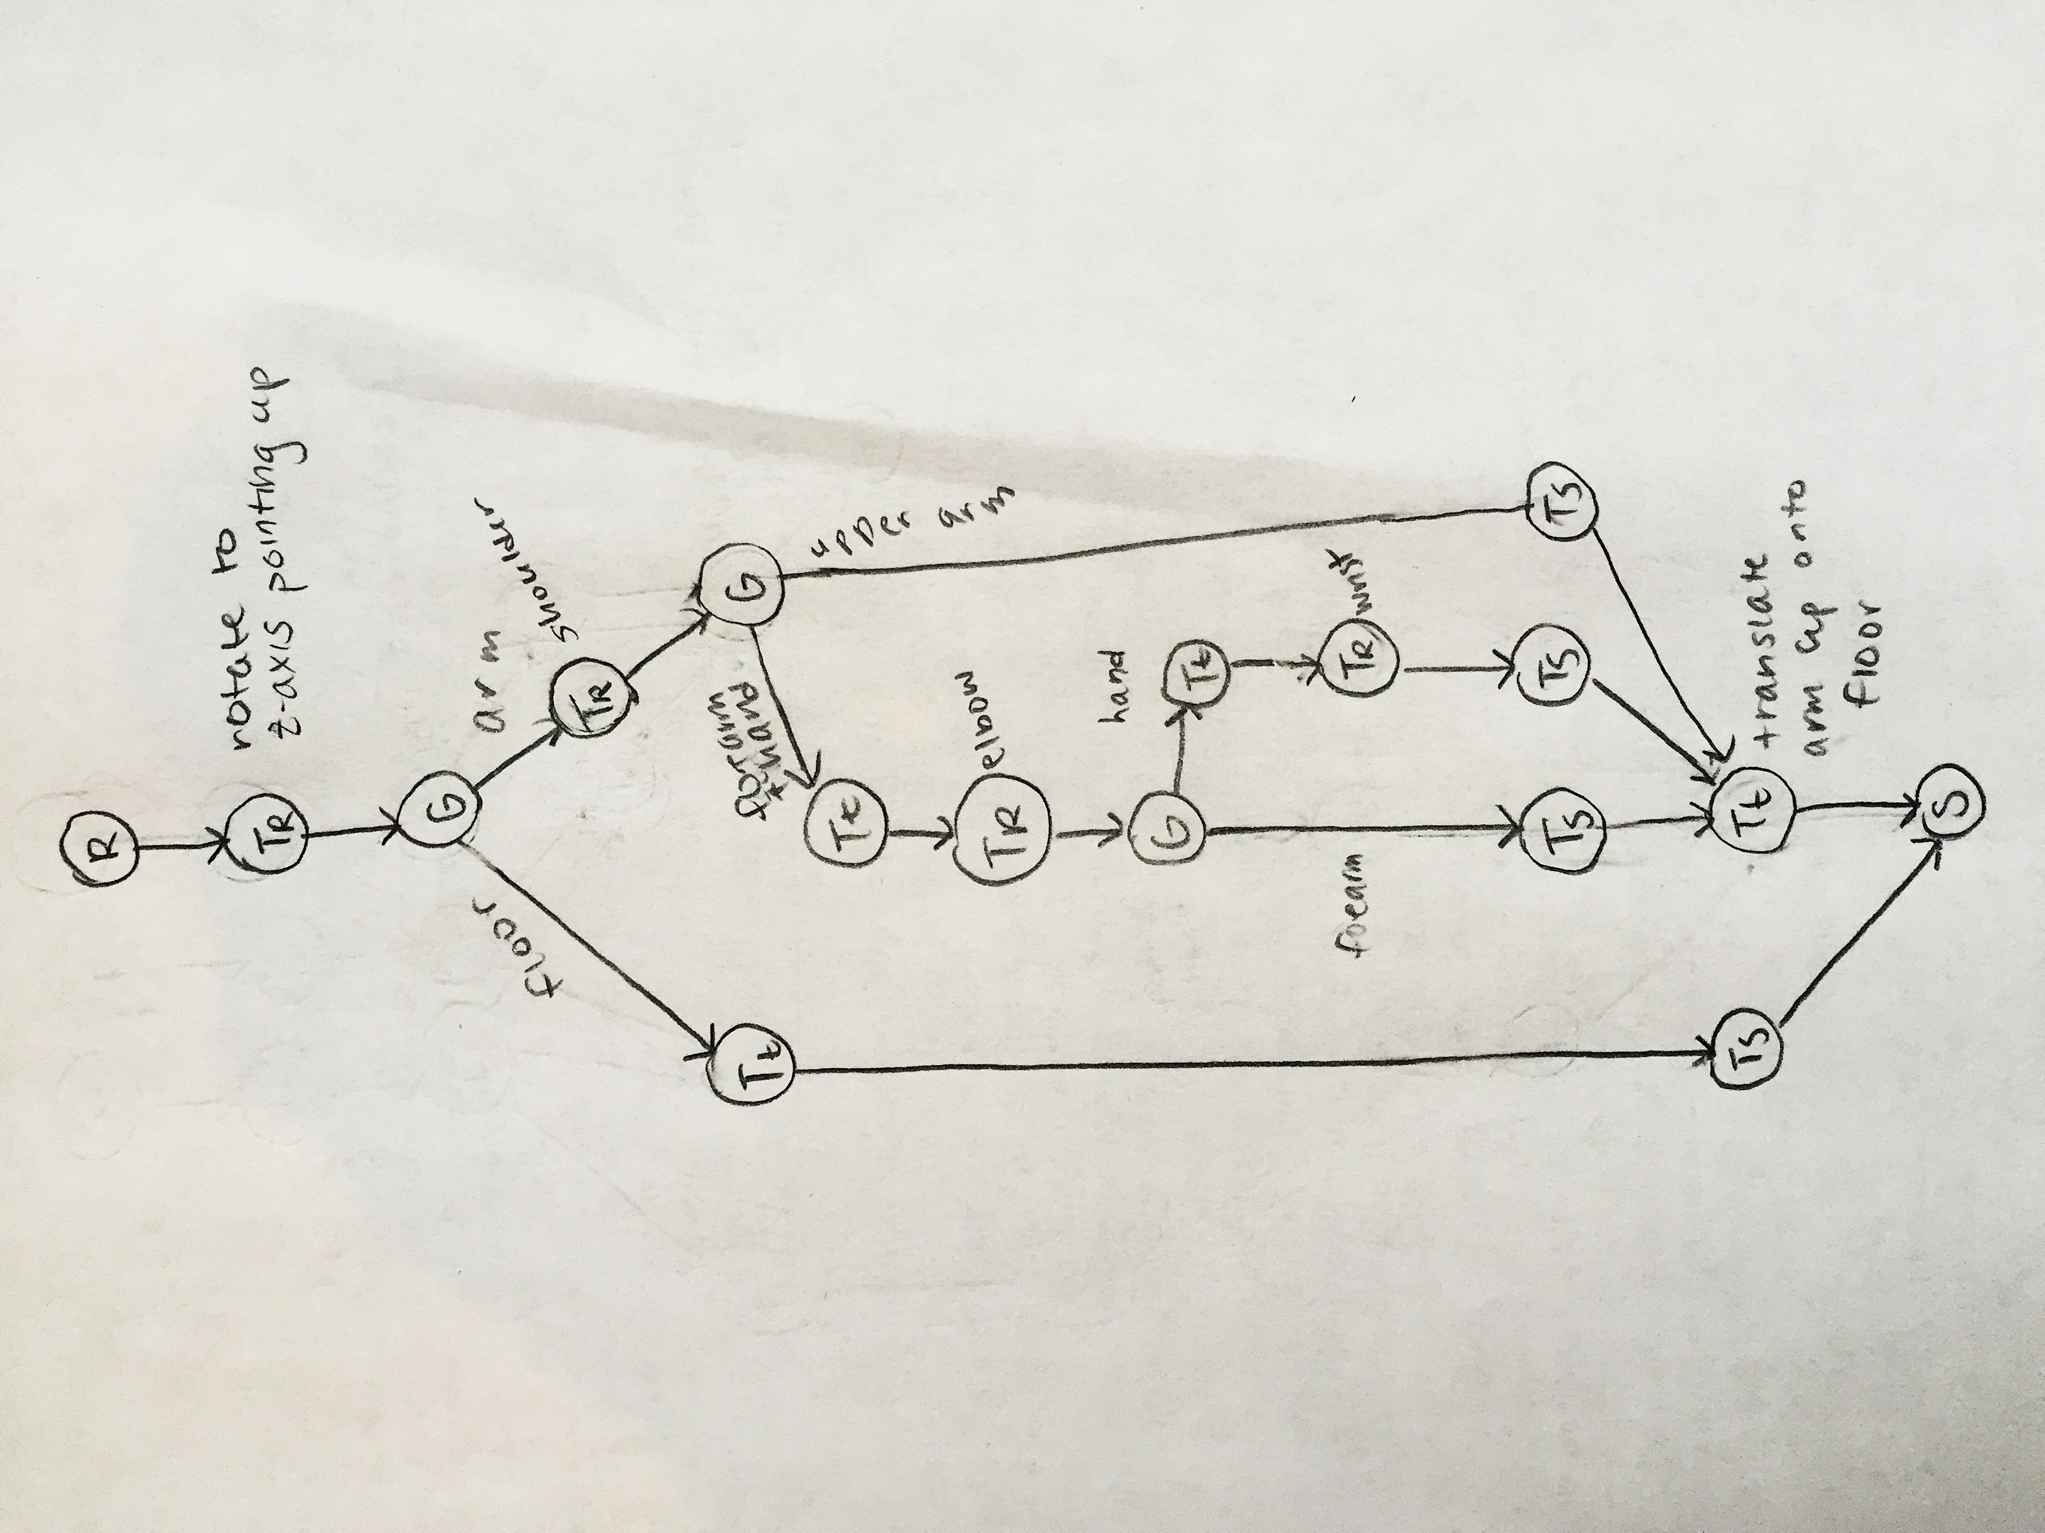1. Robotic-Arm Scenegraph

2. Robotic-Arm Screenshots

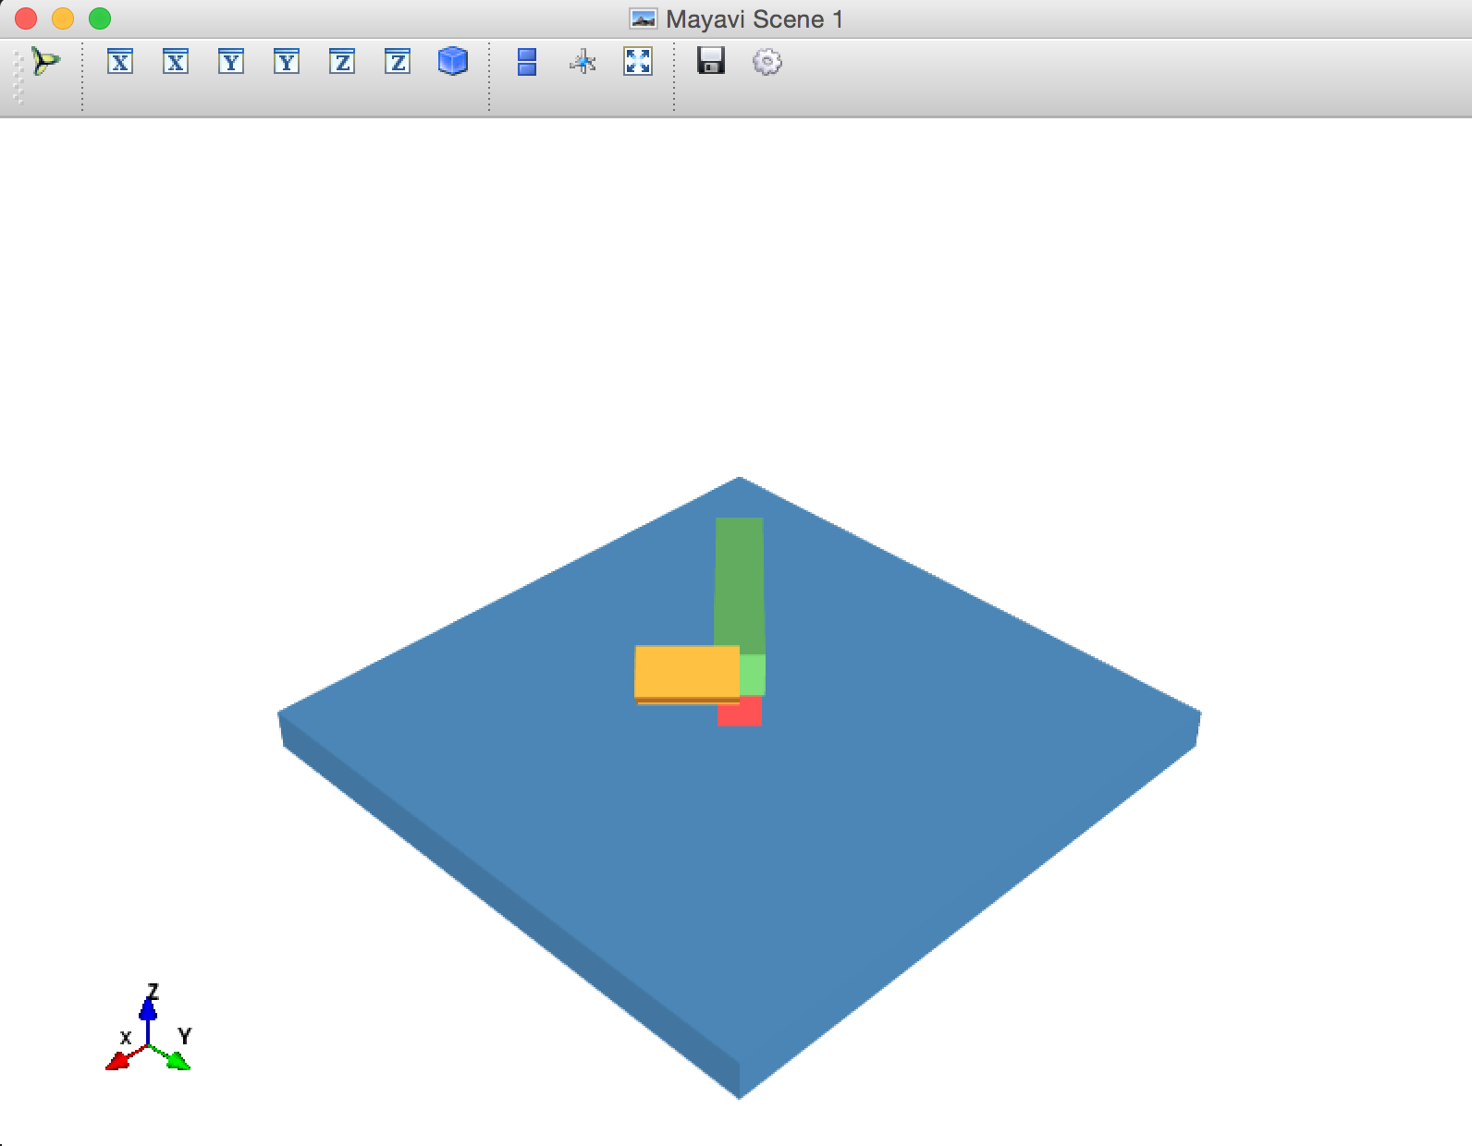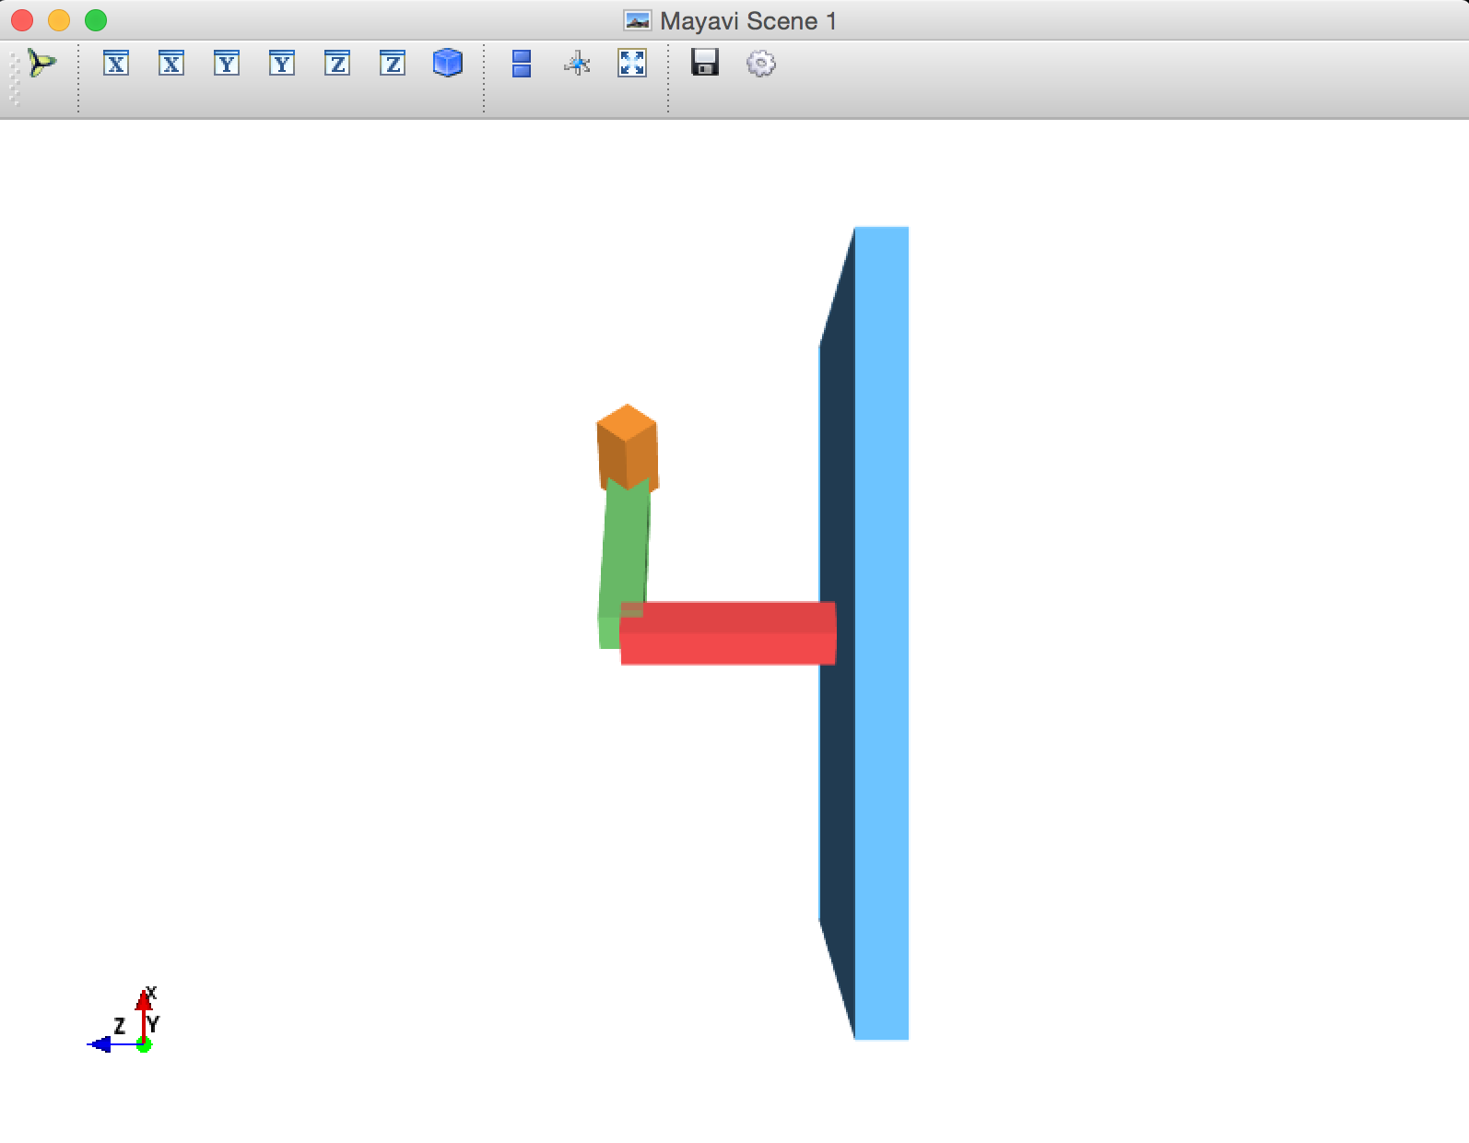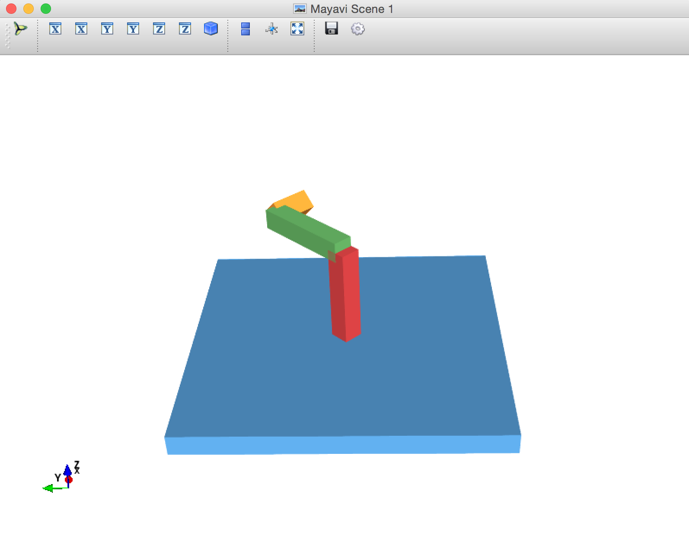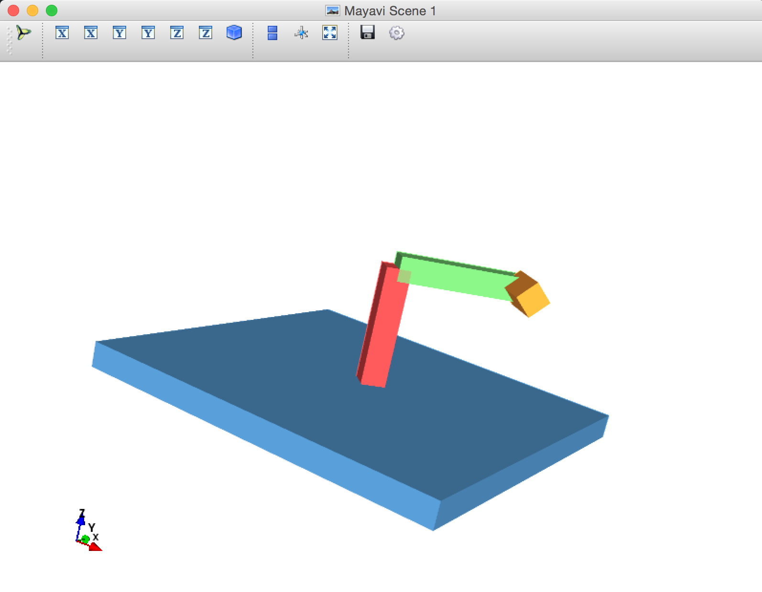

3. Description of custom scene

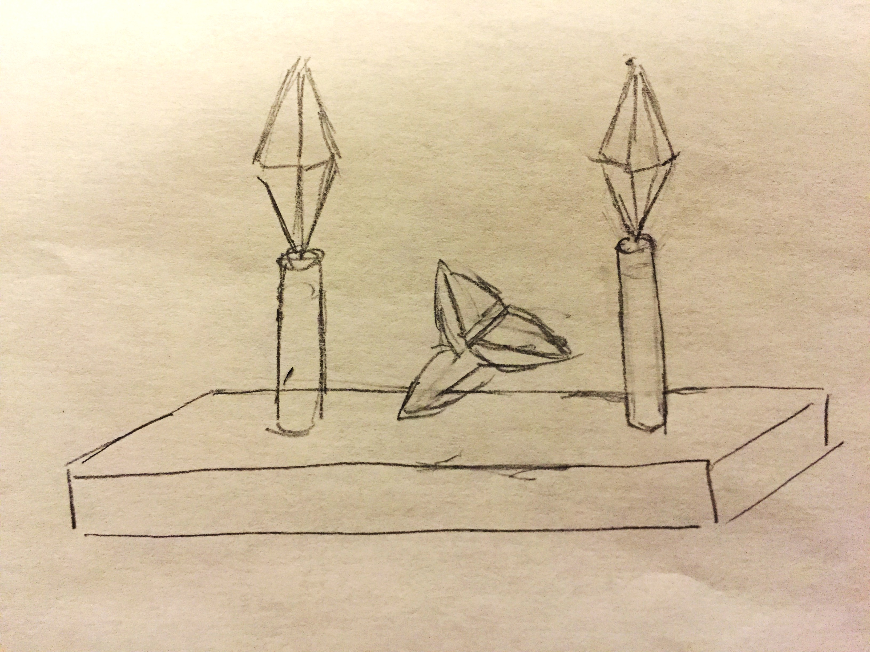

This scene depicts a squished ball between two trees. To begin, a cube is transformed into a 15x15x1 rectangular prism floor with its top face lying in the XY-plane. On the center of this floor, there is a squished ball like an imaginary little pet. This ball’s radius can be resized. On either side of this squished ball, there is a tree. Each tree is made up of a cylinder for the trunk and a double cone for the leaves and branches. These trees protect the pet squished ball and can sway freely in the wind. Like the robotic arm, the trees’ roots are fixed in place, but the tree can rotate at its roots and at the top of its trunk. One can also adjust the height of the trees.

4. Custom Scene Scenegraph

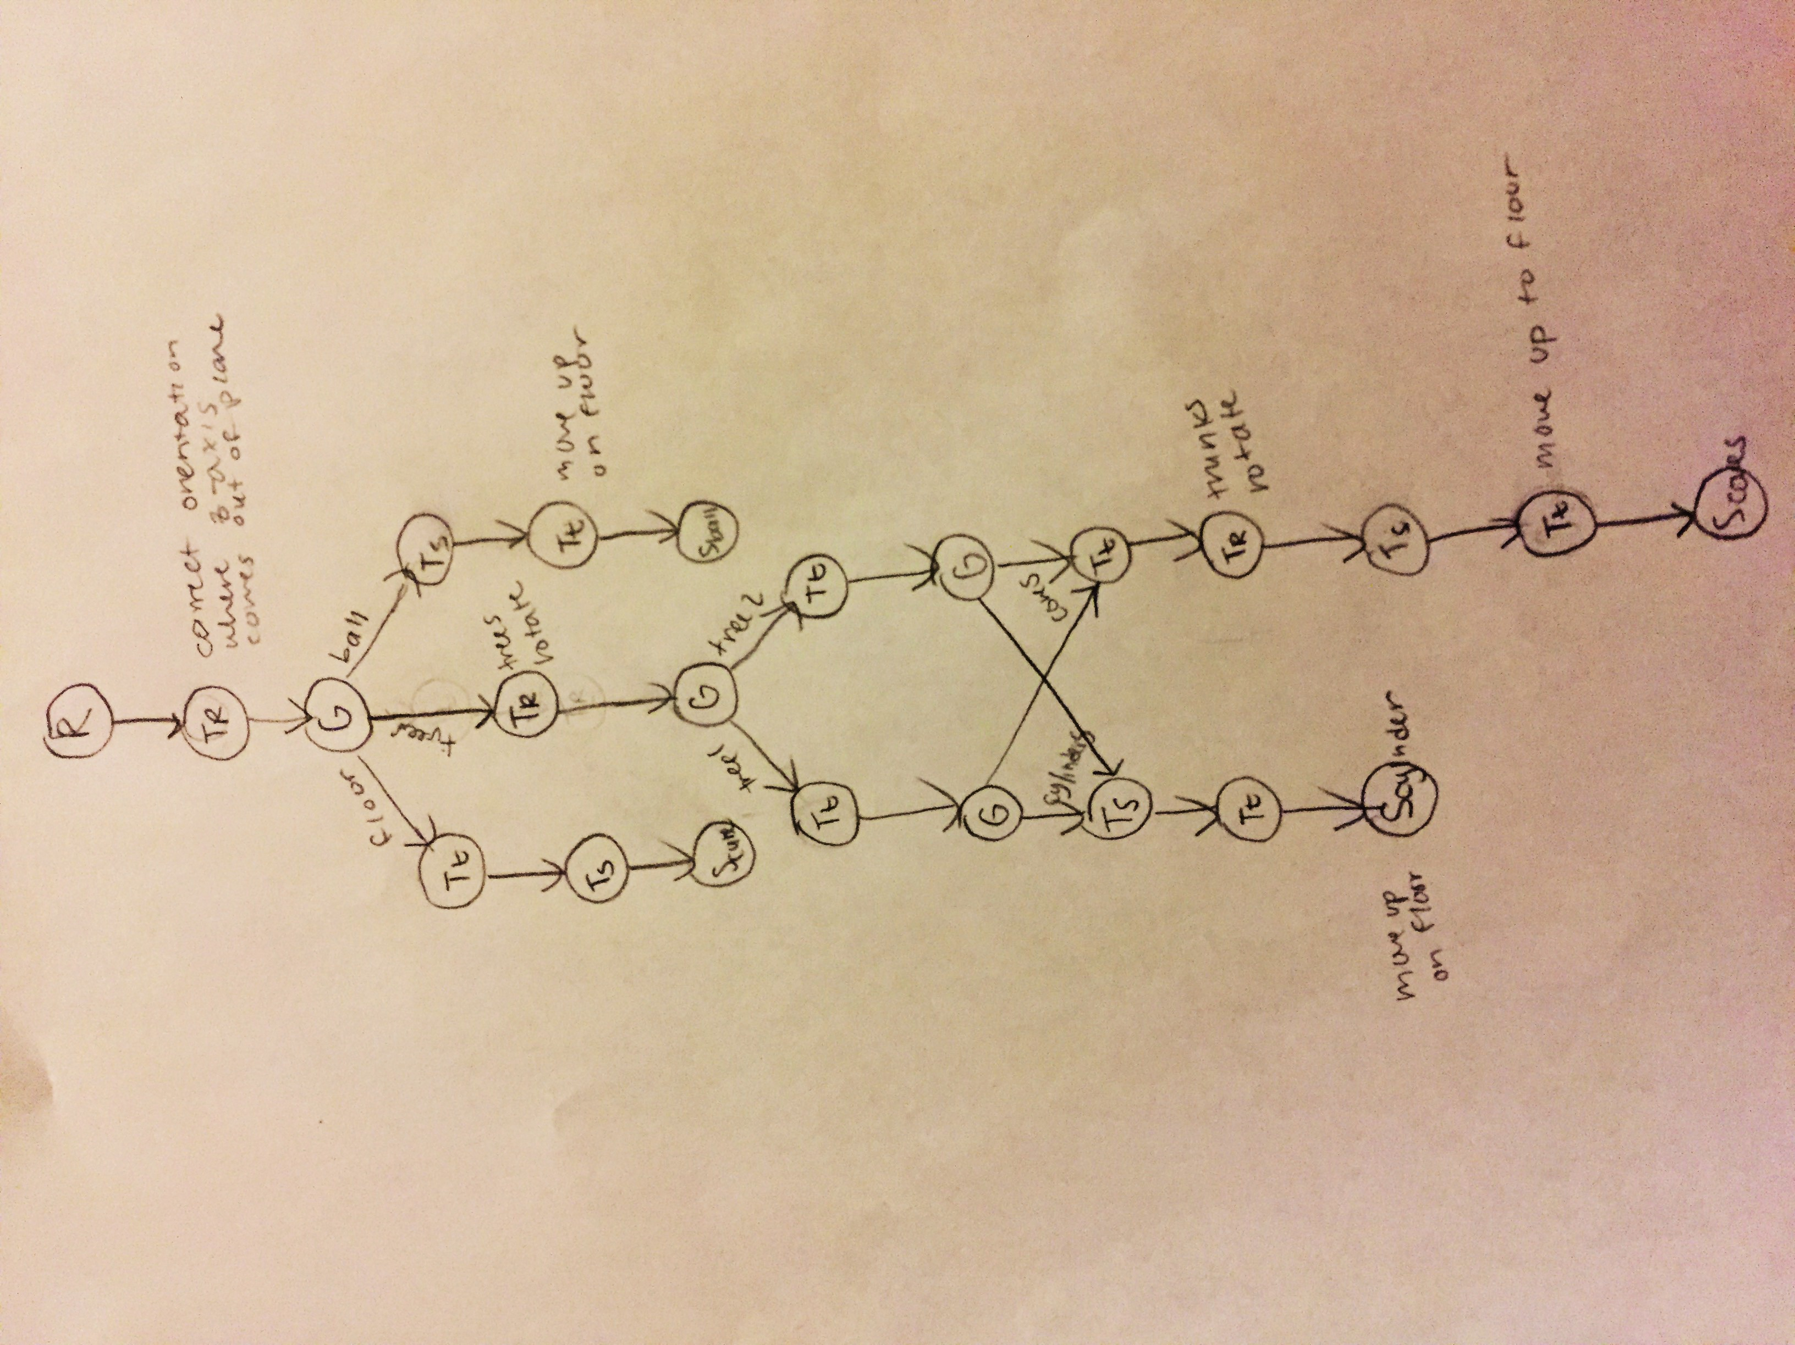

5. Screenshots of Custom Scene

